yum install epel-release

yum install python-pip

pip install awsebcli --upgrade –user

export PATH=~/.local/bin:$PATH

git clone https://github.com/aws/aws-elastic-beanstalk-cli-setup.git

./aws-elastic-beanstalk-cli-setup//scripts/bundled_installer

Reference:

sudo amazon-linux-extras install epel

15 pip install awsebcli --upgrade --user

16 yum install python-pip

17 pip install awsebcli --upgrade --user

18 eb --version

19 export PATH=$PATH;%USERPROFILE%\AppData\roaming\Python\Python37\scripts

20 export PATH=$PATH;%USERPROFILE%\\AppData\\roaming\\Python\\Python37\\scripts

21 cd /home

22 cd ..

23 ls -a

24 cd /usr/

25 ls -a

26 cd ..

27 cd /home

28 ls -a

29 cd ec2-user/

30 ls -a

31 sudo pip3 install --upgrade pip

32 pip3 install awsebcli --upgrade --user

33 vi .bash_profile

34 pip --version

35 pip install awsebcli --upgrade --user

36 eb --version

37 echo 'export PATH="/home/ec2-user/.ebcli-virtual-env/executables:$PATH"' >> ~/.bash_profile && source ~/.bash_profile

38 eb --version

39 pip install --upgrade awsebcli

40 pip3 install awsebcli

41 vi ~/.bash_profile

42 export PATH=~/.local/bin:$PATH

43 eb –version

**Blue green deployment:**

Create clone of the environment on which first version is deployed.

Upload new version on cloned env. New change is on cloned env.

Action -> Swap environment urls. Choose the env u want to swap this new version with (old version env)

**Create and deploy worker env:**

For long running workloads.

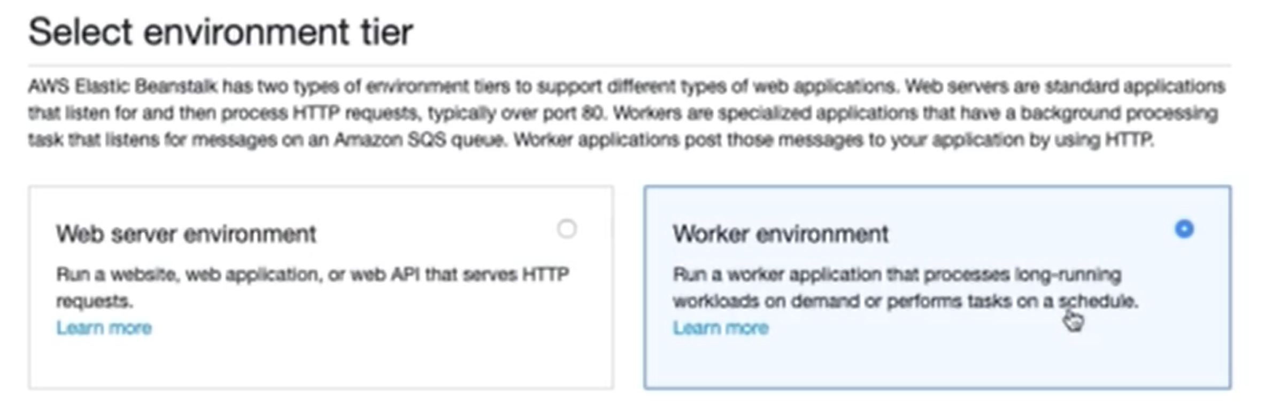

Used for long running tasks/ schedulers. In this case, a queue would be listening for messages, on message would be making a post request to root url passing I the message body

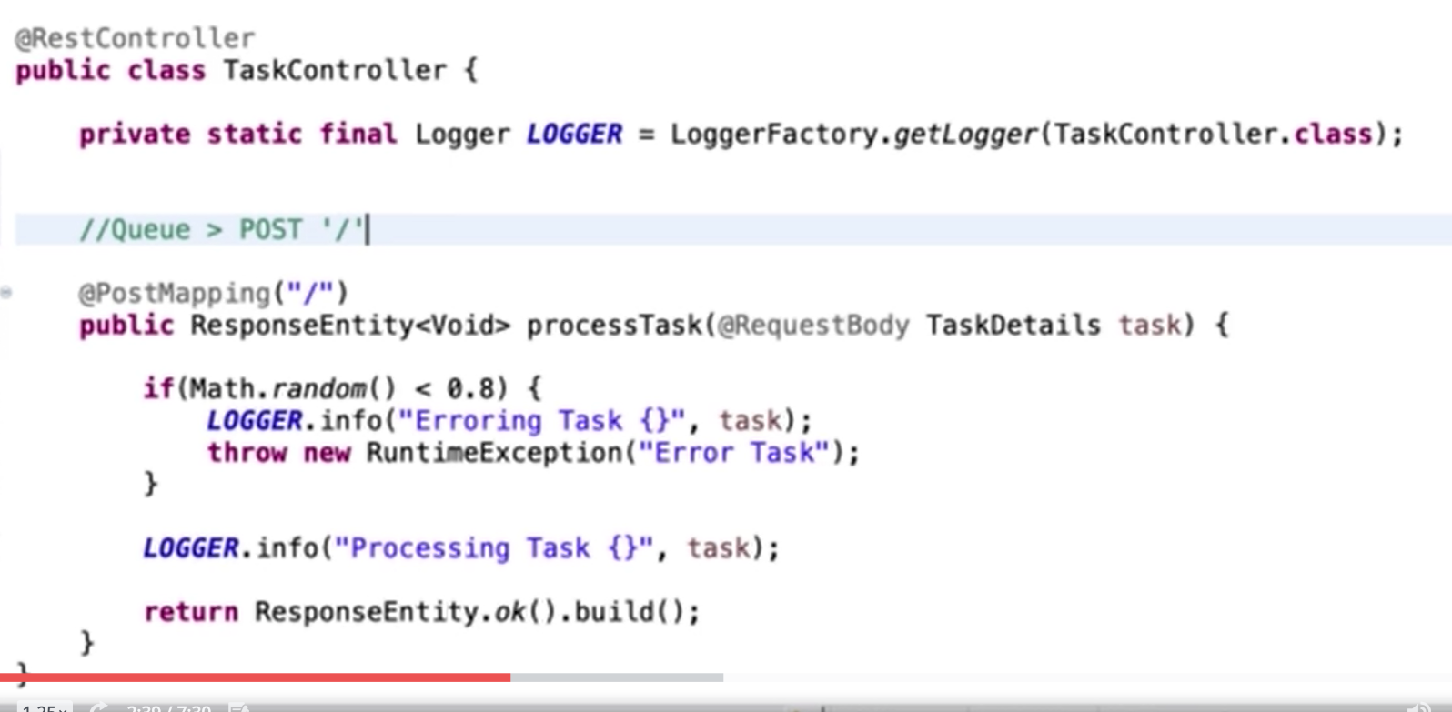

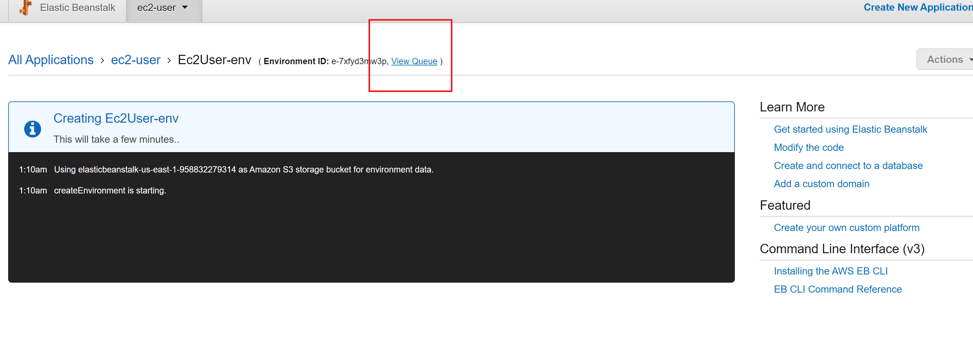

On worker env, we get the option of view queue. WE can see the queue and a dead letter queue. No messages being queued initially. By default message is retried 10 times and later moved to ddl. We can send message on worker queue

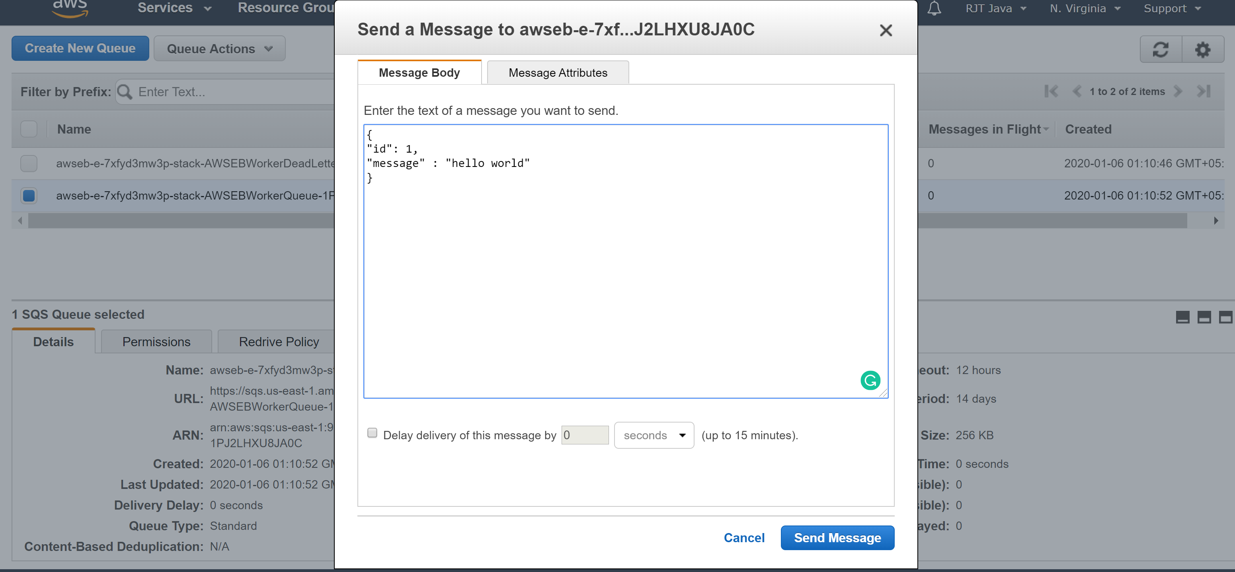

Successful messages are processed and removed from queue, unprocessed messages are retired after 5 mins again and later sent to ddl-queue.

**Auto scaling:**

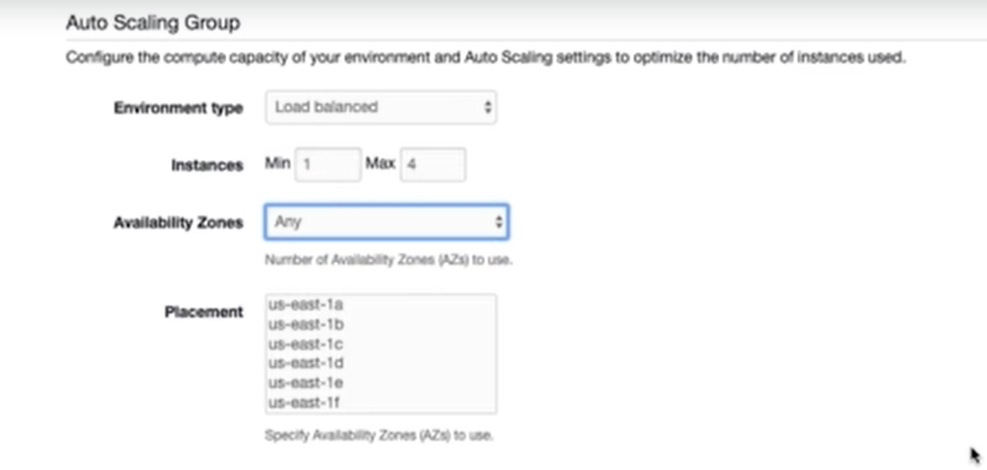

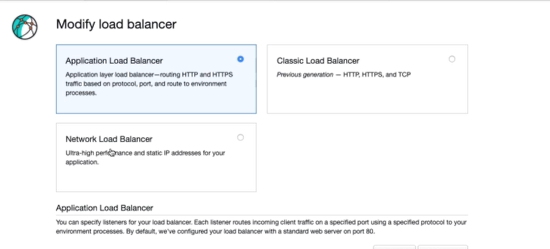

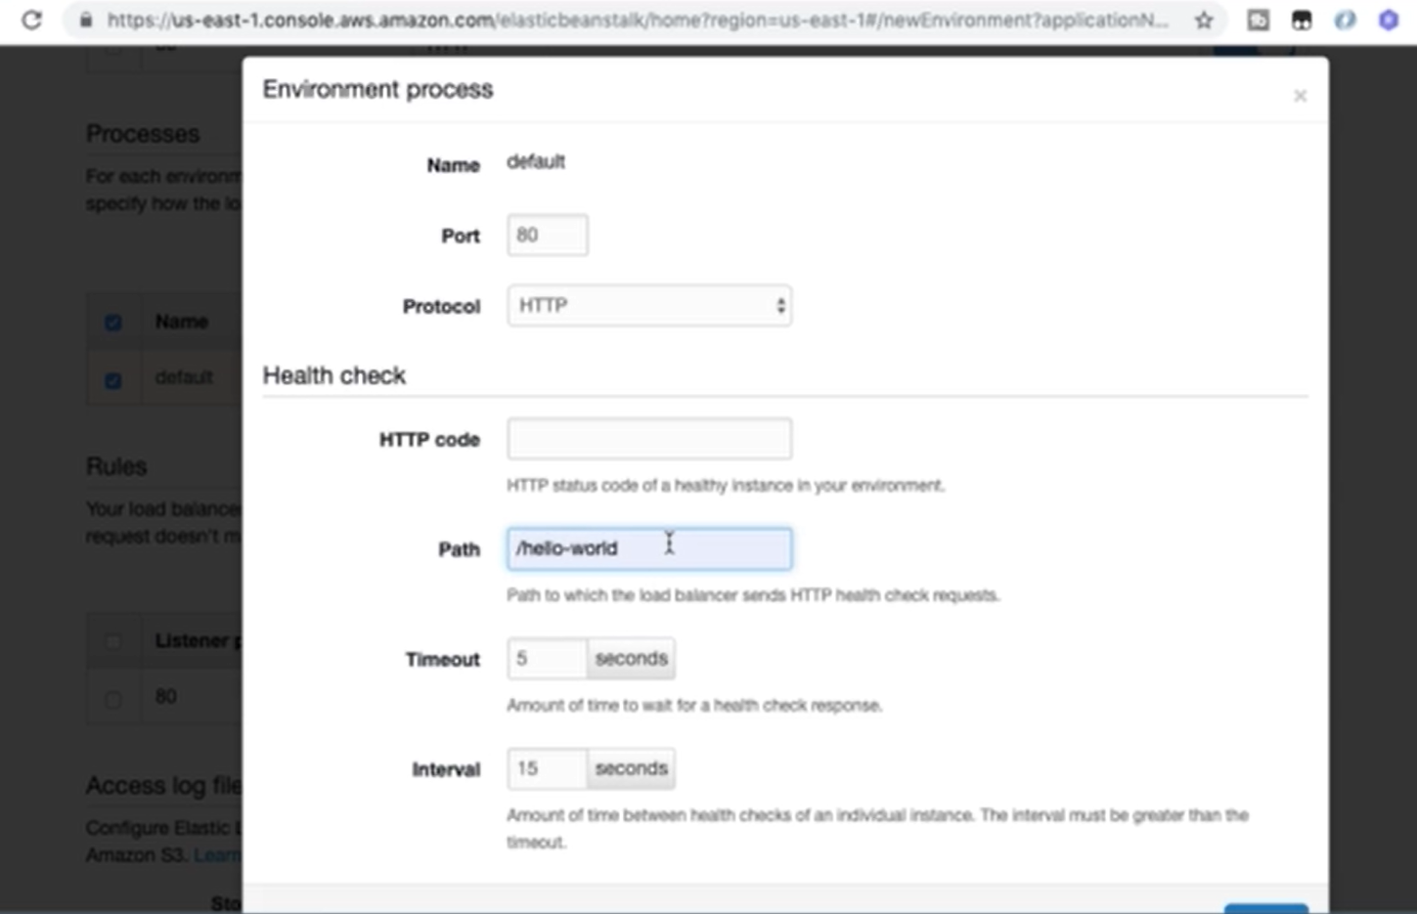

**After 15 sec, load balancer will send a request to /hello-world and if no response, will know that instance is not up and will not route any request to that instance.**

**Rolling with additional batch: If 1 instance is running, will start new instance, push updates on that instance**

**Rolling: can specify batch size, if 1 , means if 4 instances are present will push updates on 1 at a time.**

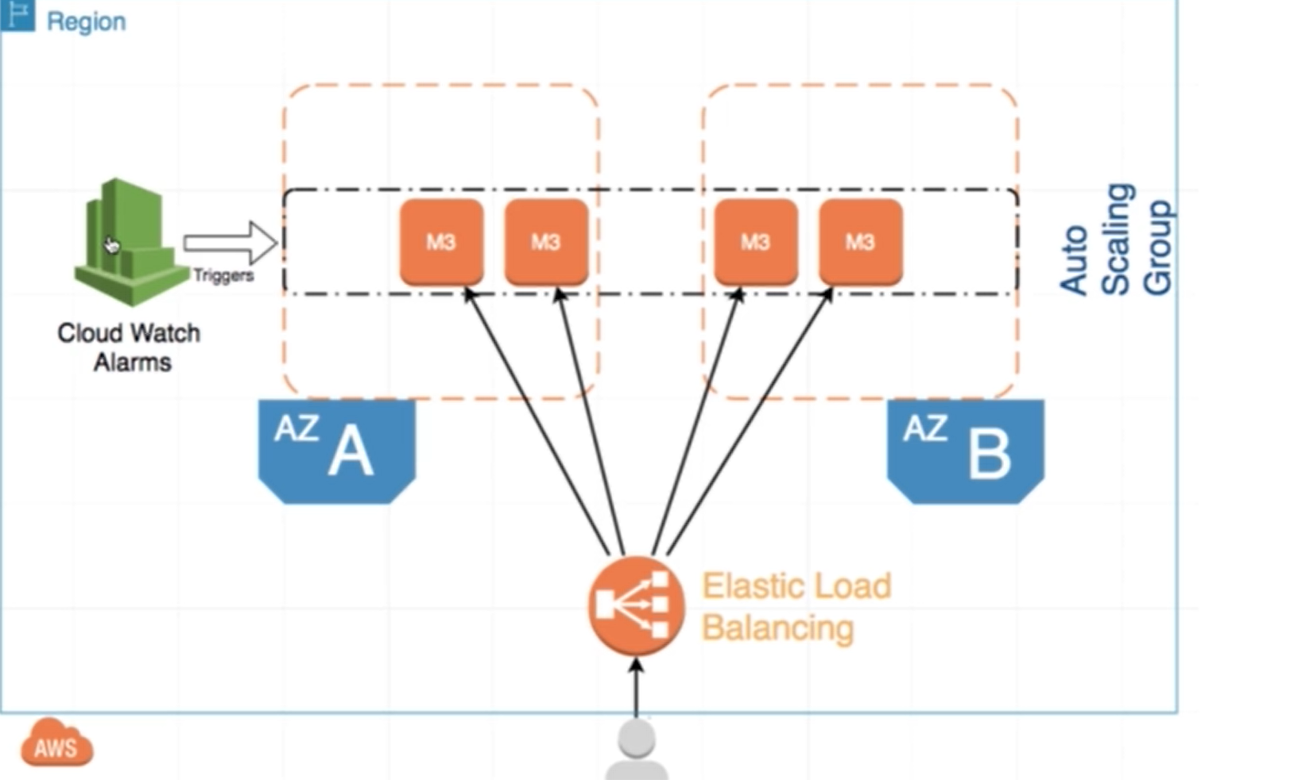

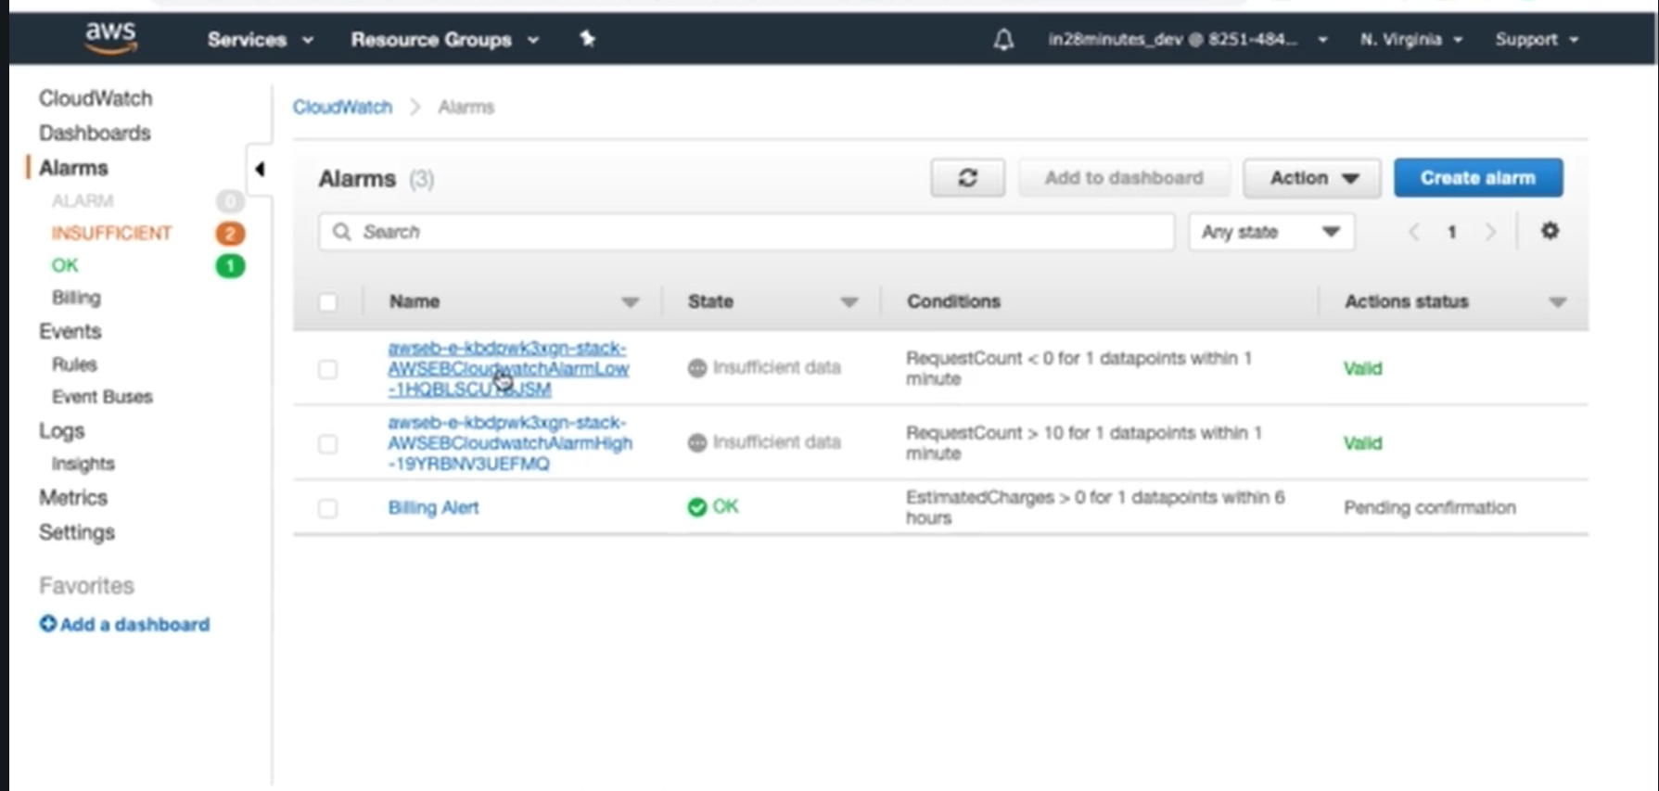

**Autoscaling alarms**

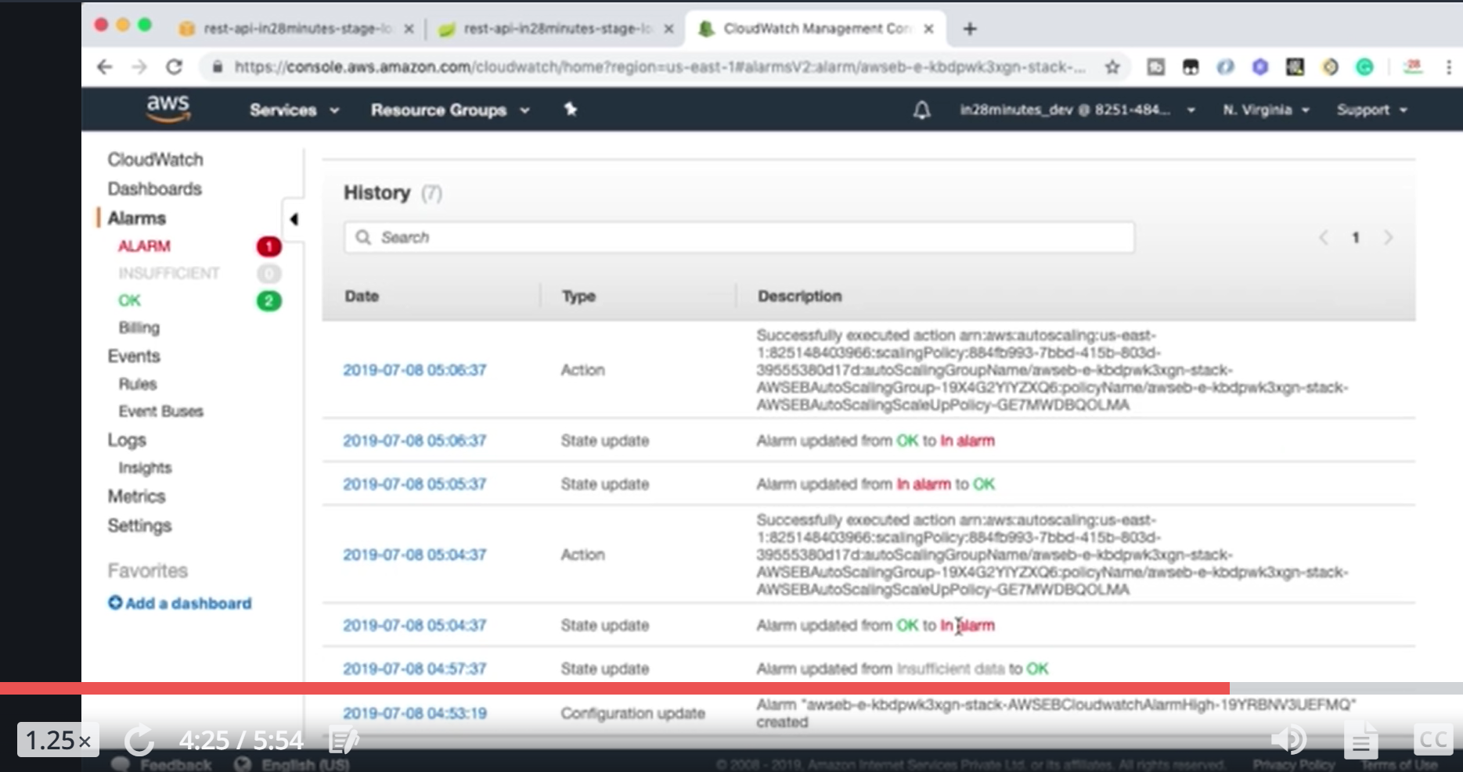

**Code Pipeline:**

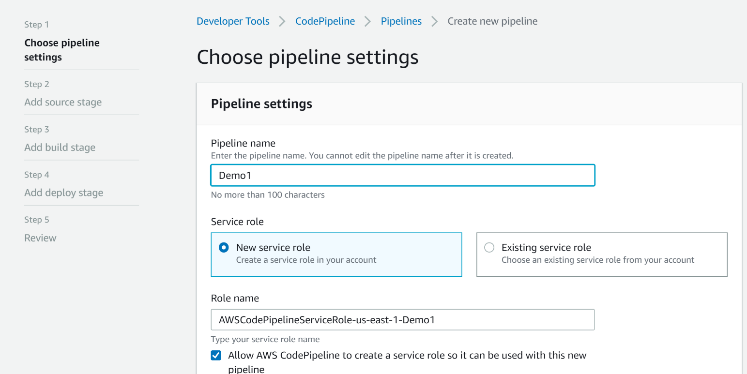

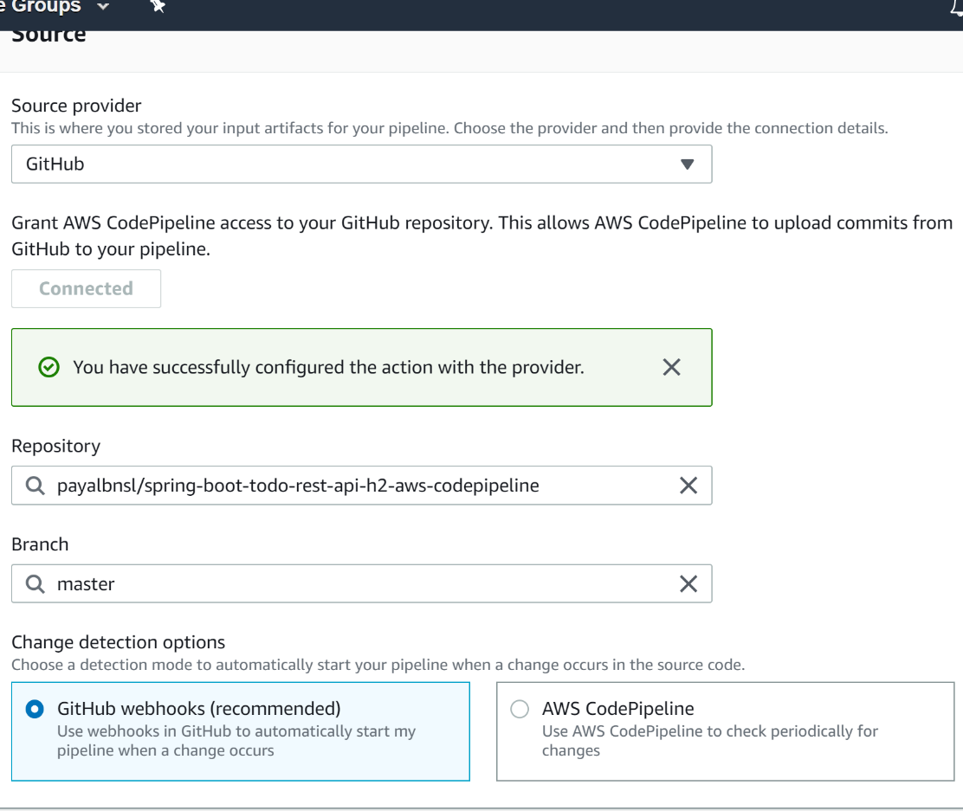

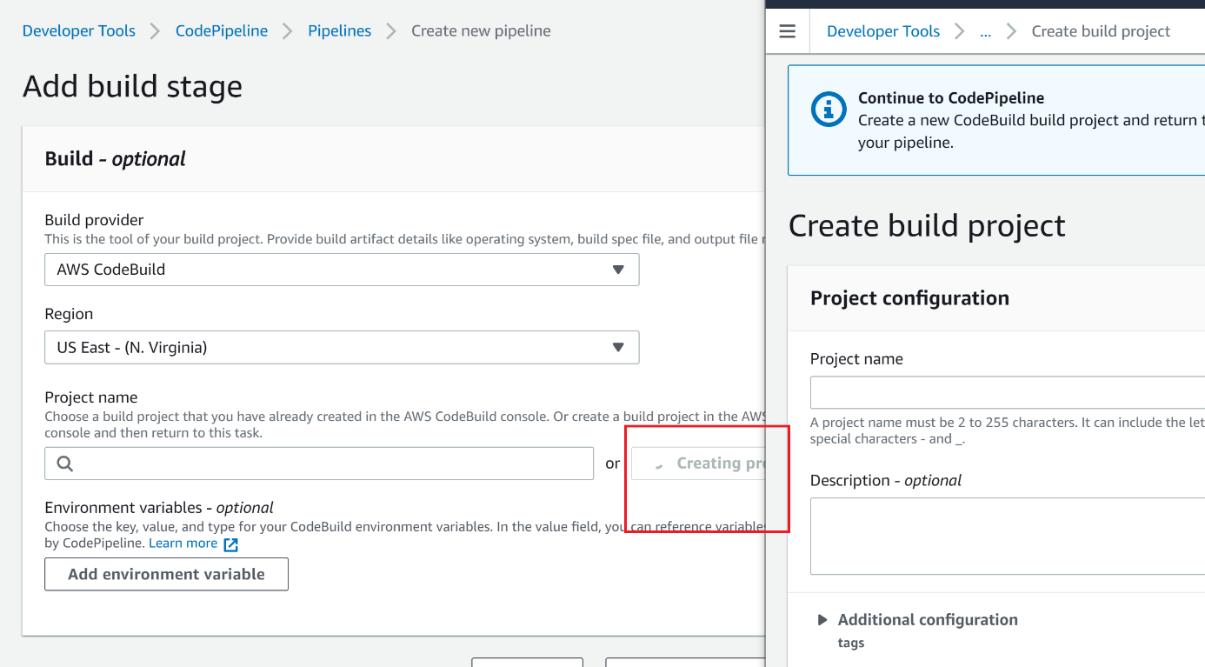

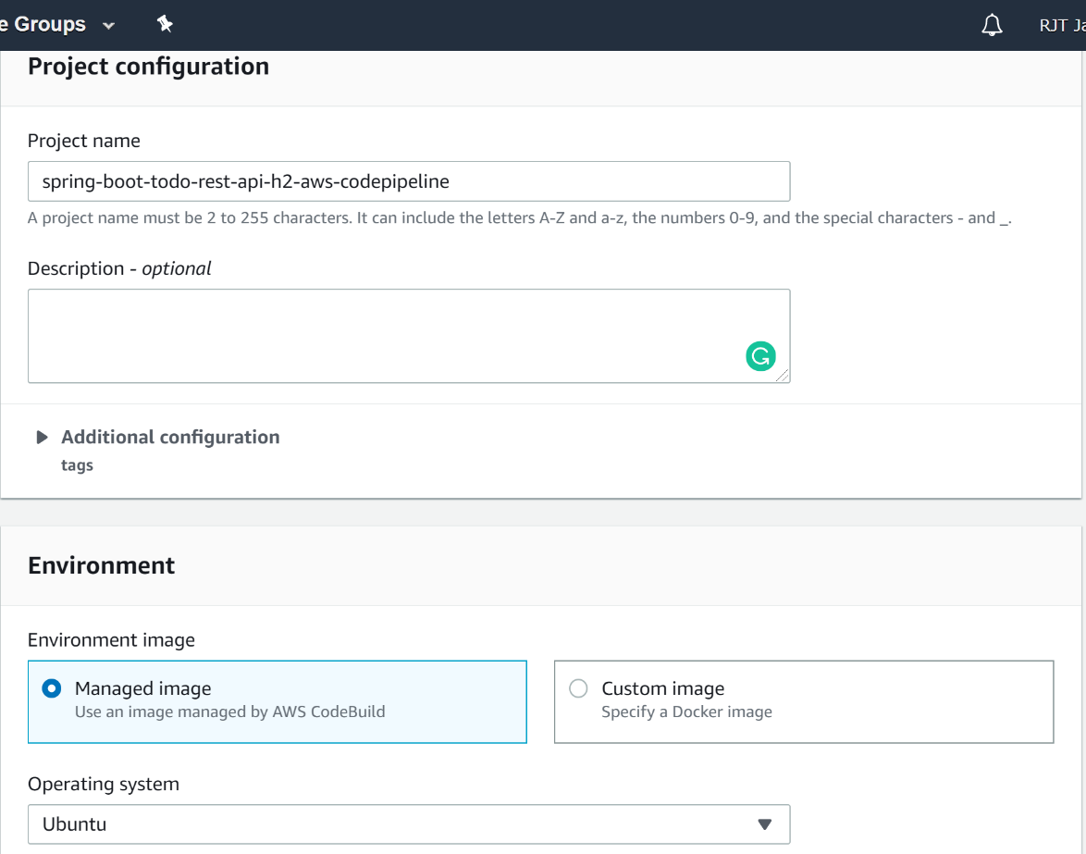

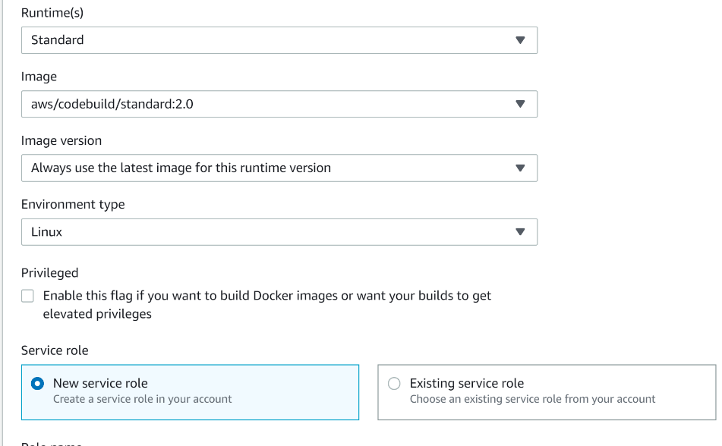

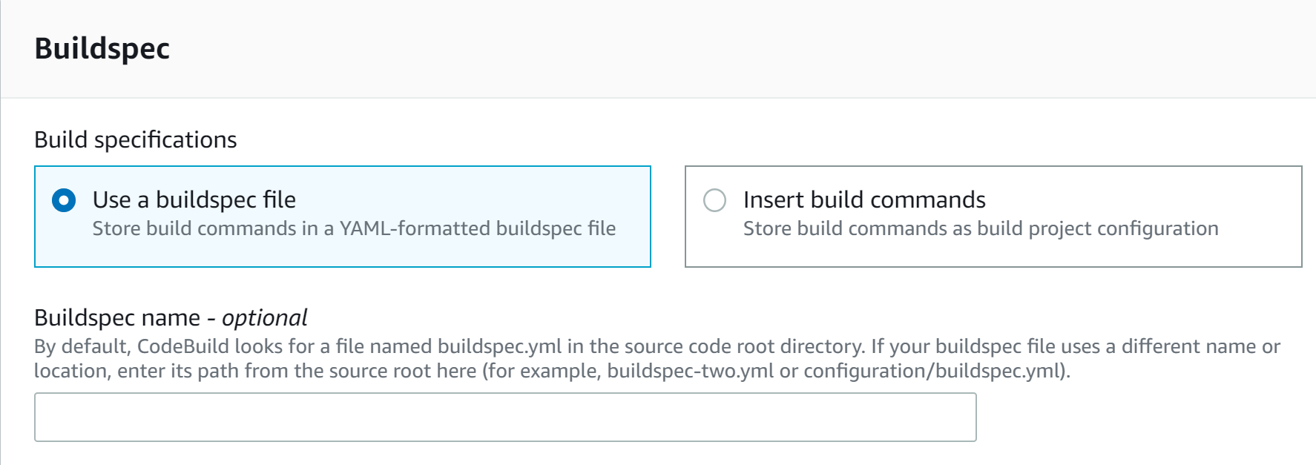

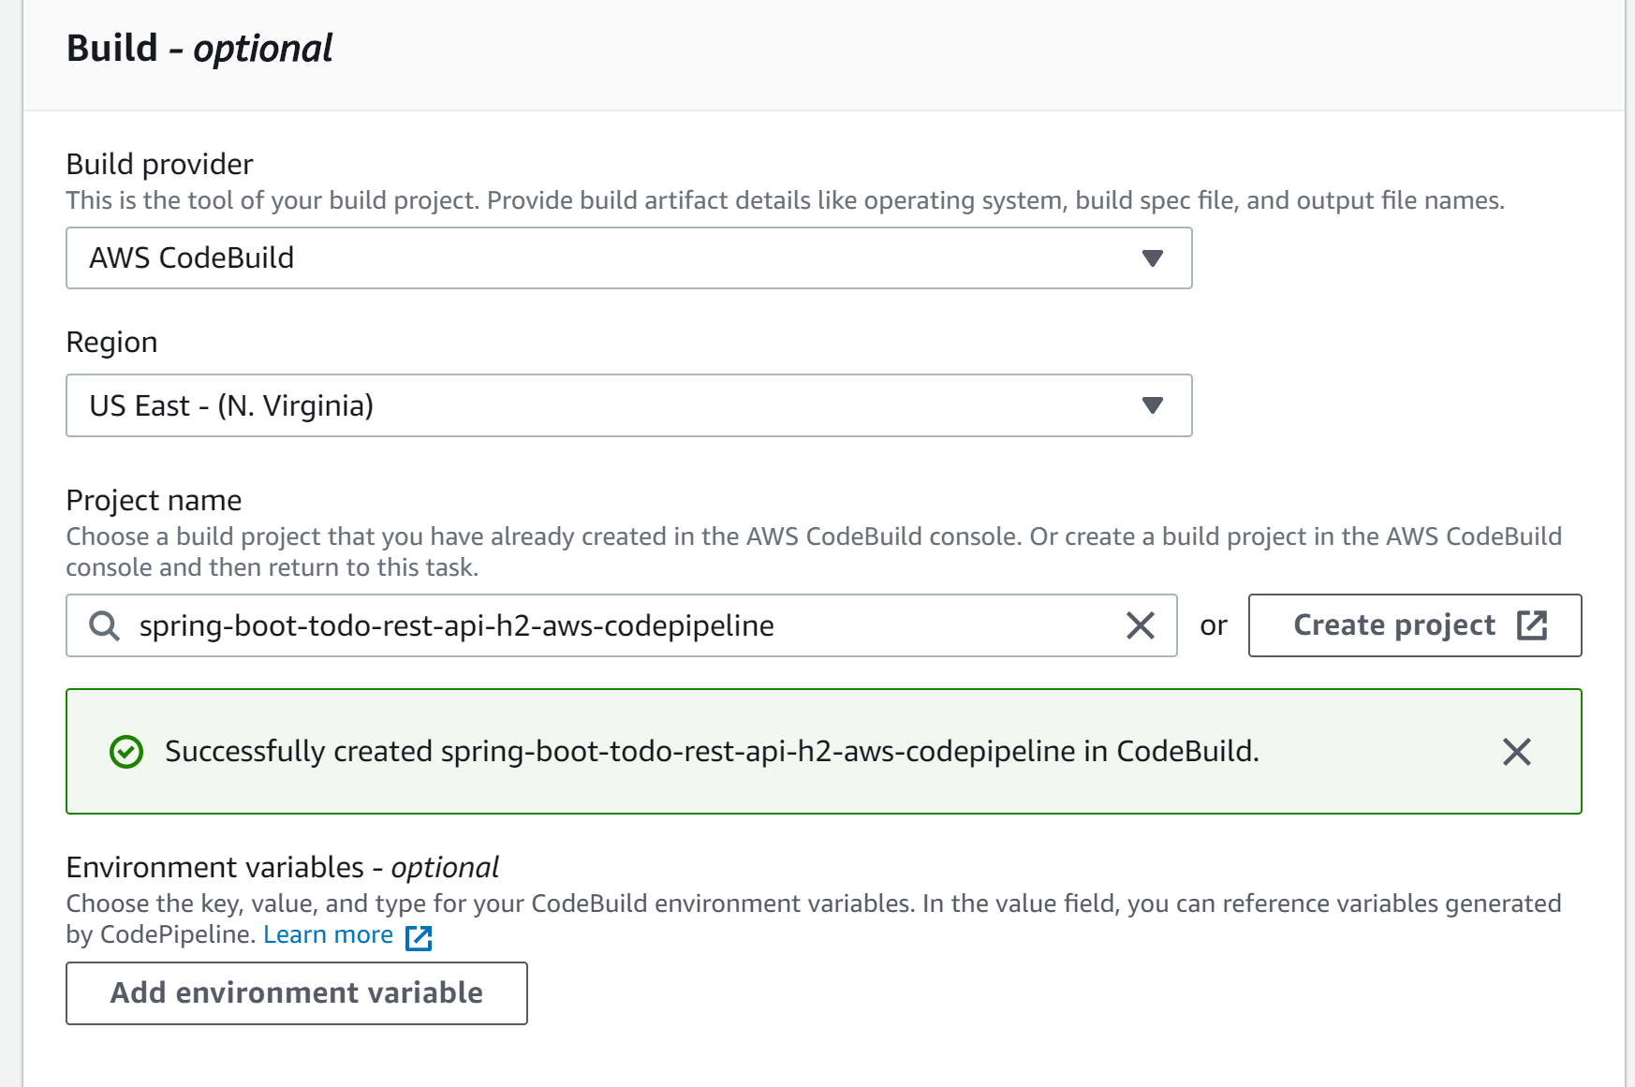

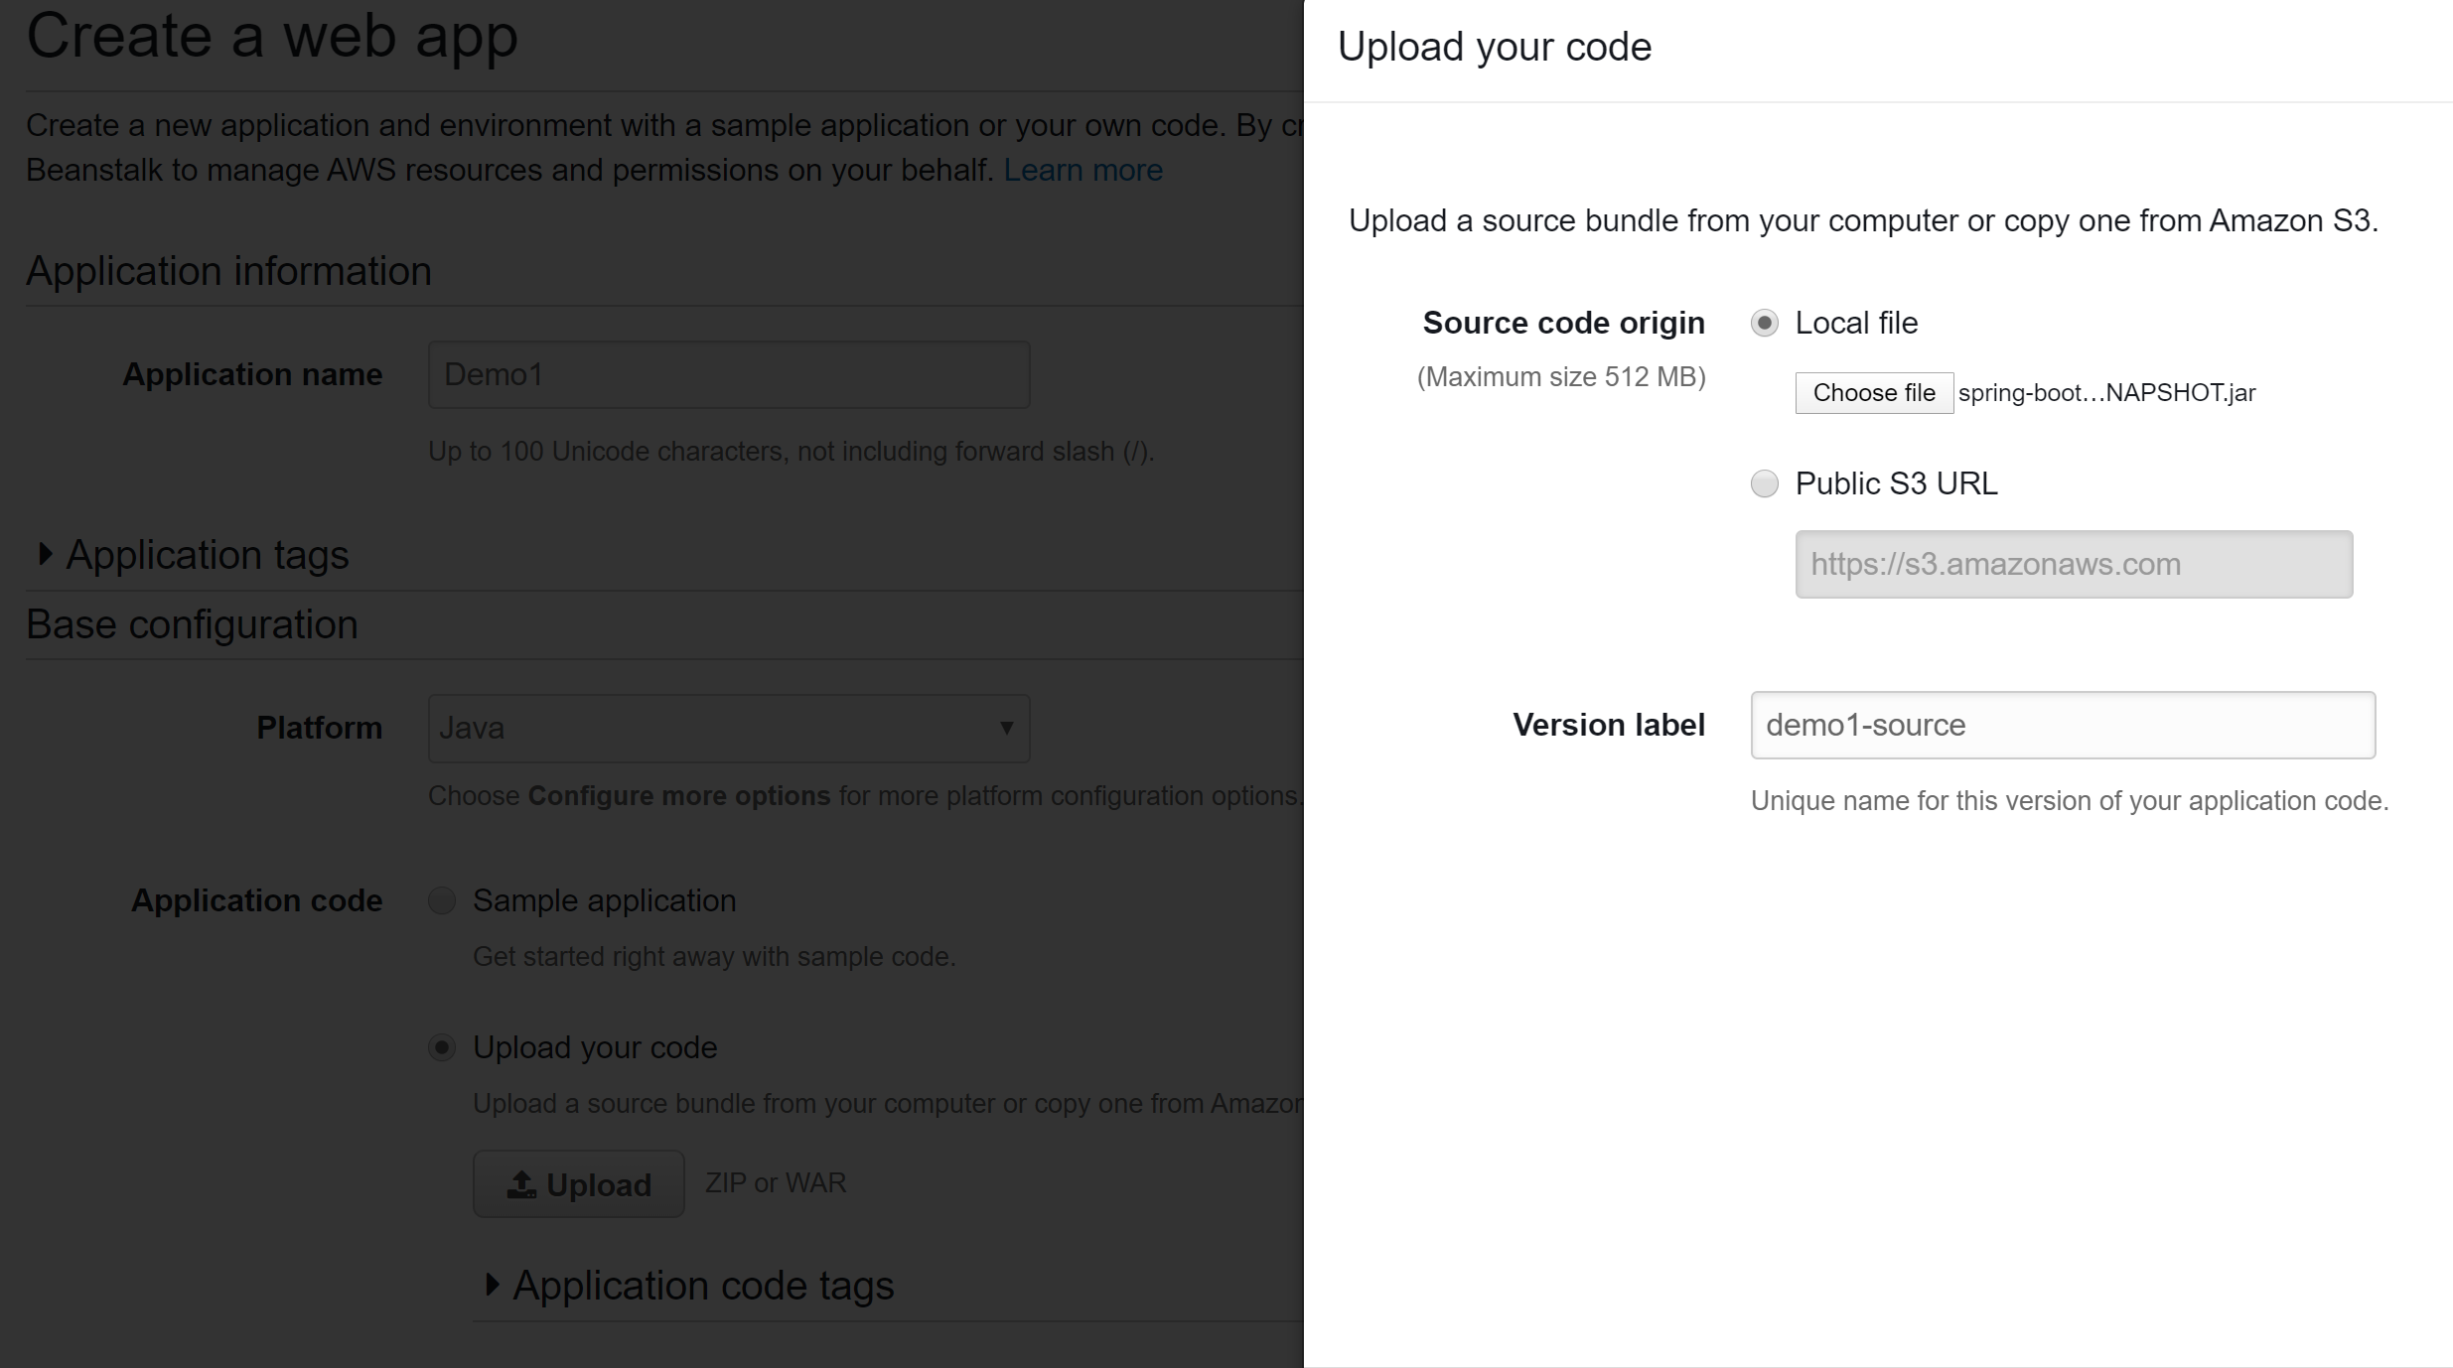

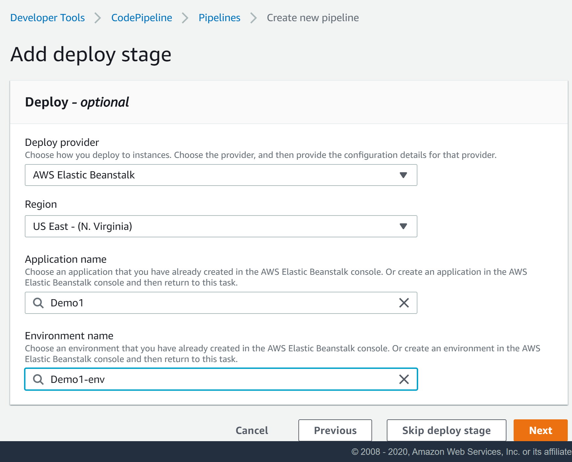

 by default, the build spec file must be named buildspec.yml and placed in the root of your source directory.

<https://docs.aws.amazon.com/codebuild/latest/userguide/build-spec-ref.html>